Array Communications & Processing

Experiment: AM

Supervisor of Experiment: Prof. A. Manikas

Demonstrator: Zhuqing Tang

Student: Ilias Chrysovergis, [ic517@ic.ac.uk](mailto:ic517@ic.ac.uk), 01449042

1. The initial pattern is given in the following figure:

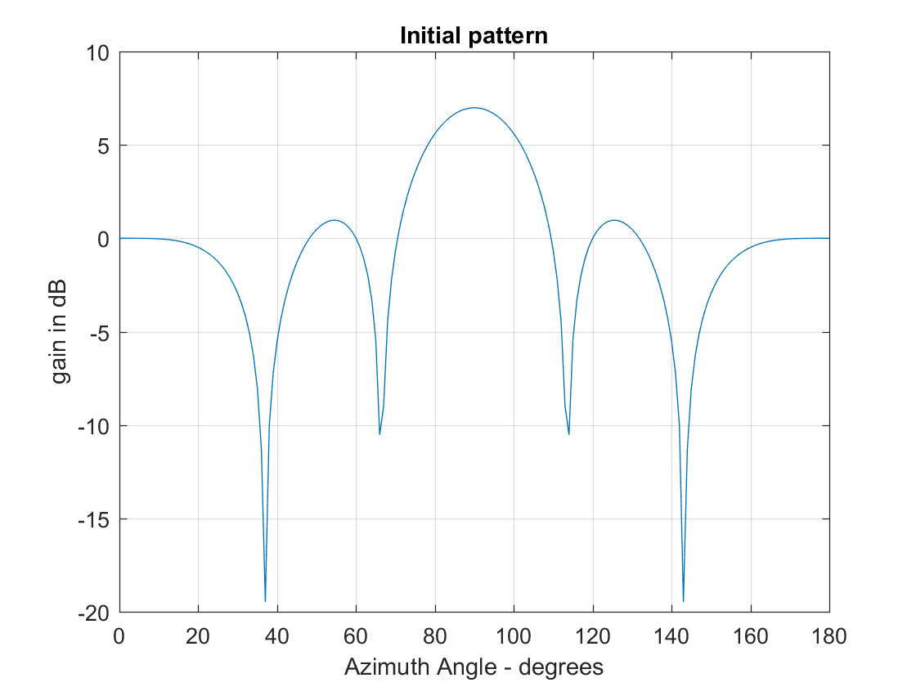

The gain provided by the array for the three sources is given in the following table:

|  |  |
| --- | --- |
| **DOA of each source** | **Gain (dB)** |
| 90, 0 | 7 |
| 35, 0 | -8 |
| 30,0 | -3 |

1. The answers for the 2nd question are given below:
   * + For the first and the second source, the antenna in the middle receives the signal without a phase shift. For the third source (at 90 degrees) there is no phase shift at all. That is the reason why there is maximum gain at that angle.
     + The Covariance Matrix of the three sources is given below:
$$R_{mm}=\begin{matrix}1 & 0 & 0 \\ 0 & 1 & 0 \\ 0 & 0 & 1\end{matrix}$$

2. The audio signal that one can listen is only noise. No melody or some other kind of information can be distinguished. The image output of the second antenna is given below:

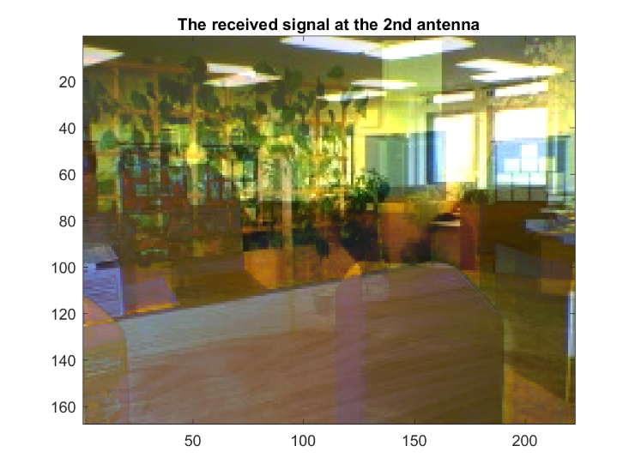

1. Just forget what I already know about the system.
2. The eigenvalues of the theoretical covariance matrix are the following ones:

9.9369, 4.9681, 0.0953, 0.0001, 0.0001

It can be seen that the smallest eigenvalue is equal to the power of noise. Furthermore, if someone subtracts the power of noise from the eigenvalue vector, he/she will be able to find the number of sources, by counting how many non-zero elements the new vector has. Therefore, by looking at the covariance matrix above, one can find the minimum element of it and estimate that the power of noise is equal to 0.0001. Finally, by substracting the power of noise, only 3 non-zeros can be found in the vector. So, 3 sources are present.

Theorem:

Suppose that $R_{xx}$ is the covariance matrix of the signals at the input of an array. By applying eigenvalue decomposition to that matrix, the eigenvalue vector is known. The minimum of this vector is equal to the power of noise, while the non-zero elements of the eigenvalues vector subtracted by the power noise corresponds to the number of sources that are present.

The eigenvalues for the covariance matrix of the audio signals are given below:

1.0e+05 * (0.0000, 0.0000, 0.0017, 0.1072, 4.3818)

Since the maximum eigenvalue is greater than ${10}^{5}$ and MATLAB does not provide us with a very precise number the power of noise seems to be equal to zero. However, if the results were more precise, and more digits where provided the power of the noise could be identified. Furthermore, the non-zero elements of the eigenvalue vector give us the number of the sources.

The eigenvalues for the covariance matrix of the image signals are given below:

1.0e+05 * (0.0000, 0.0000. 0.0019, 0.2039, 2.1784)

Same comments can be made for the image signals.

Therefore, the validity of the above theorem can be applied to practical covariance matrices too. But, one should have in mind that for practical covariance matrices the power of noise is not fixed and so all the eigenvalues that correspond to noise will have different values. This problem can be resolved by using a specific precision for the eigenvalues. A better solution for this problem will be discussed on question 13 where the AIC and the MDL criteria are going to be presented.

1. The array pattern of the array when it is weighted by $w_{opt}$ is given in the following figure:

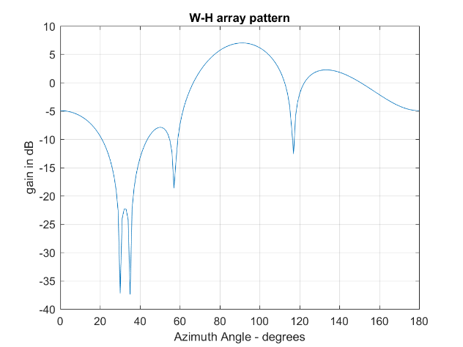

In the array pattern above, the directions of the two interferences can be distinguished at the azimuth angles of 30 and 35 degrees. The array pattern suppresses the two interferences as it provides a very small gain in these angles. Furthermore, it is obvious that the maximum gain can be found at 90 degrees. Thus, the array amplifies as much as possible the signals from that direction of arrival.

1. By having an SNR equal to 10 dB there are a lot of changes in the system.

First of all, the eigenvalues of the theoretical covariance matrix are the following ones:

10.0368, 5.0680, 0.1952, 0.1000, 0.1000

The same observations can be made from here too. The smallest eigenvalues show the power of the noise, while the non-zero elements of the vector after substracting the power of noise show us the number of the sources. Furthermore, the third largest eigenvalue is very close to the power of noise. Therefore, it may be difficult to identify if that eigenvalue corresponds to noise or to an another source. This fact can be seen in the following array pattern too.

The new array pattern, weighted by the wiener-hopf solution can be seen in the following figure:

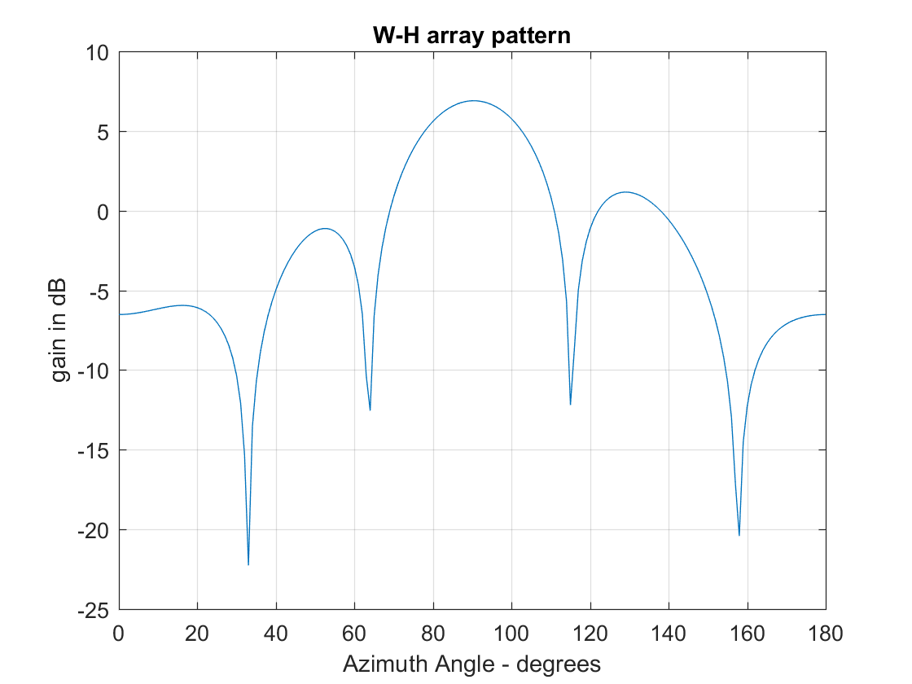

Here, only one interference can be distinguished, because the high level of noise distorts the results.

1. The main conclusion that can be drawn from 6 and 7 is that the power of noise plays a critical role in the performance of an array receiver. Low levels of SNR can lead to misunderstanding of the environment in which the array is receiving signals, since it may mislead about the number of sources.
2. The music algorithm can distinguish the direction of arrival of the sources by using only the array and the covariance matrix. The implementation of the music algorithm in Matlab can be seen below:

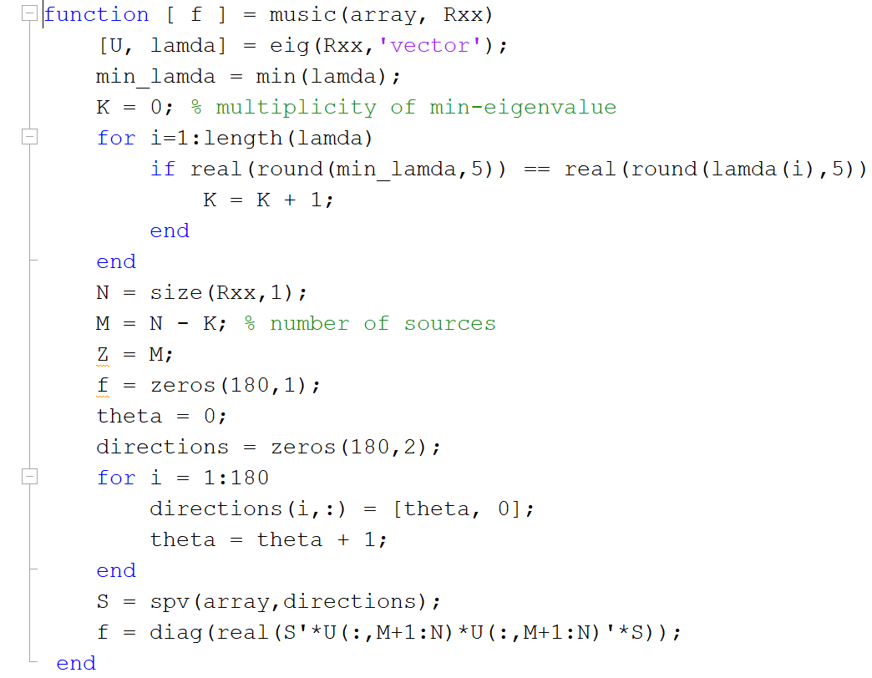

The Music spectrum is given below:

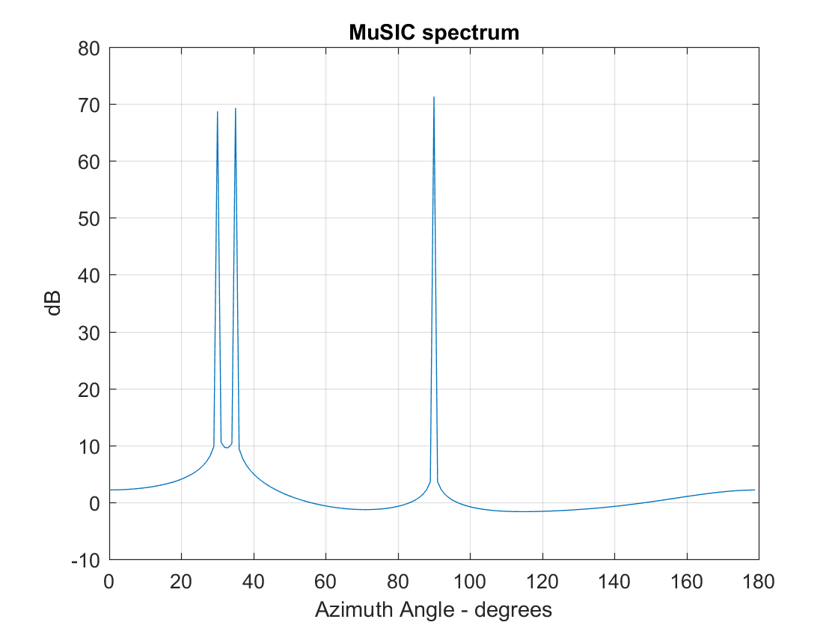

Therefore, it is obvious that the directions of arrival are at 30, 35 and 90 degrees.

1. The Music spectrum for the covariance matrix corresponding to the audio signals can be found below:

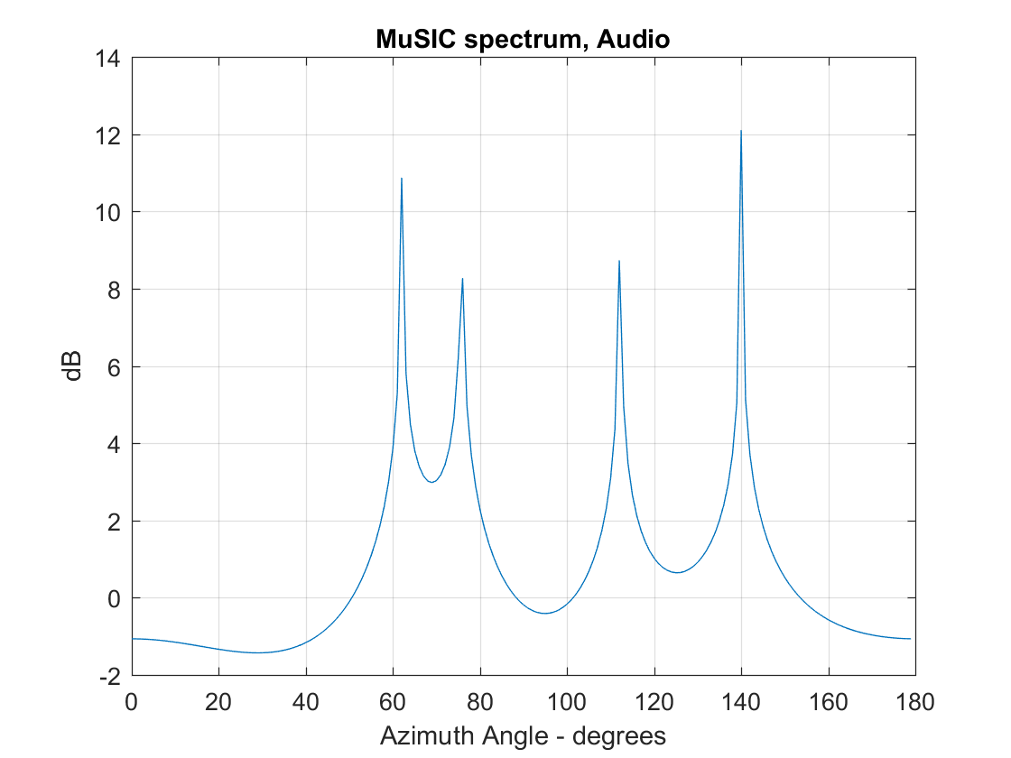

The Music spectrum for the covariance matrix corresponding to the image signals can be found below:

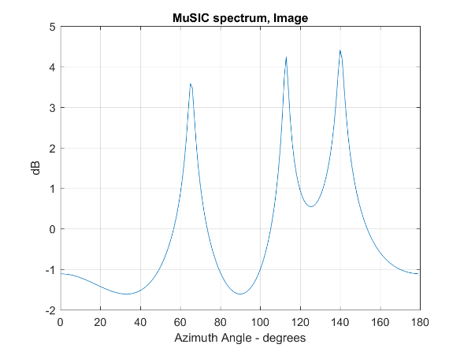

1. The Covariance Matrix of the three sources, when two of them are coherent is given below:

$$R_{mm}=\begin{matrix}1 & 1 & 0 \\ 1 & 1 & 0 \\ 0 & 0 & 1\end{matrix}$$

The eigenvalues of the above covariance matrix can be seen below:

19.8142, 4.9704, 0.0001, 0.0001, 0.0001

It is obvious that now only two image sources can be found, since three eigenvalues are equal to the power of noise. By applying the music algorithm to the new covariance matrix, we get the following result:

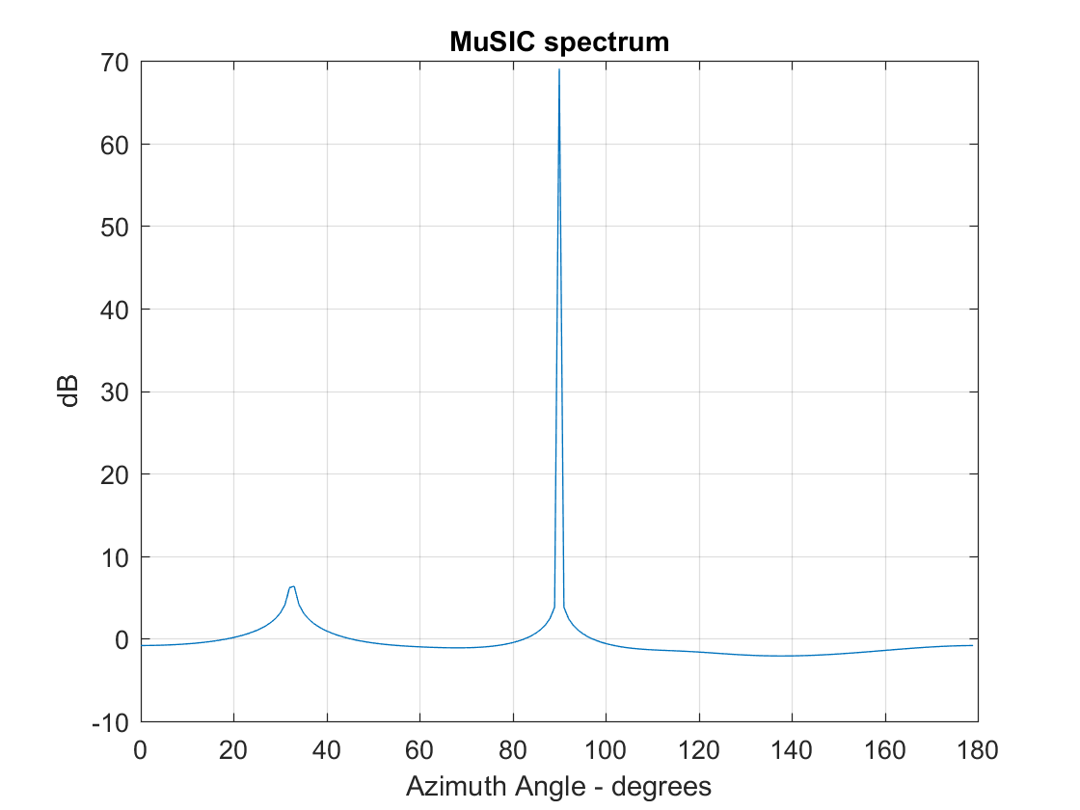

Now, only two sources can be distinguished and the second one has a very small peak.

The implementation of the spatial smoothing is given below:

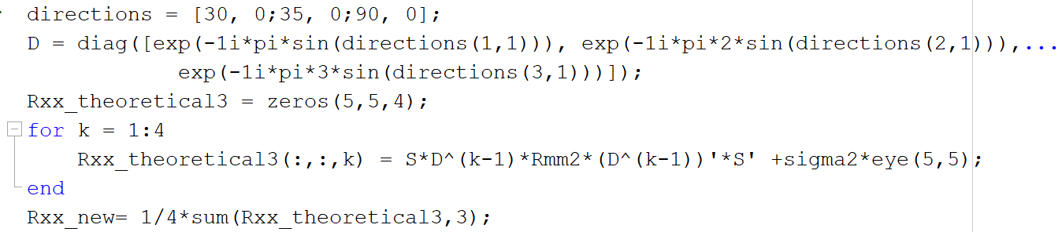

By applying the music algorithm to the new covariance matrix after the spatial smoothing we get:

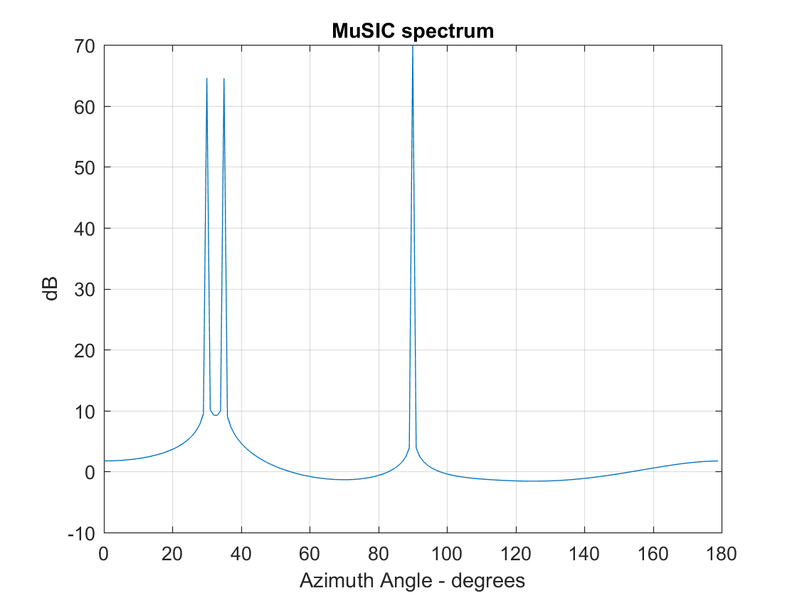

Therefore, by applying the spatial smoothing algorithm the sources can be distinguished in the case that they are coherent too.

1. By listening to the audio output, we can realize that there is a main song with interference songs from the different sources. I did not manage to understand which song is coming from the 90 degrees but from the 30 degrees it was easy to understand that the “Sweet Dreams” from Eurythmics had been transmitted.

The transmitted image is given below:

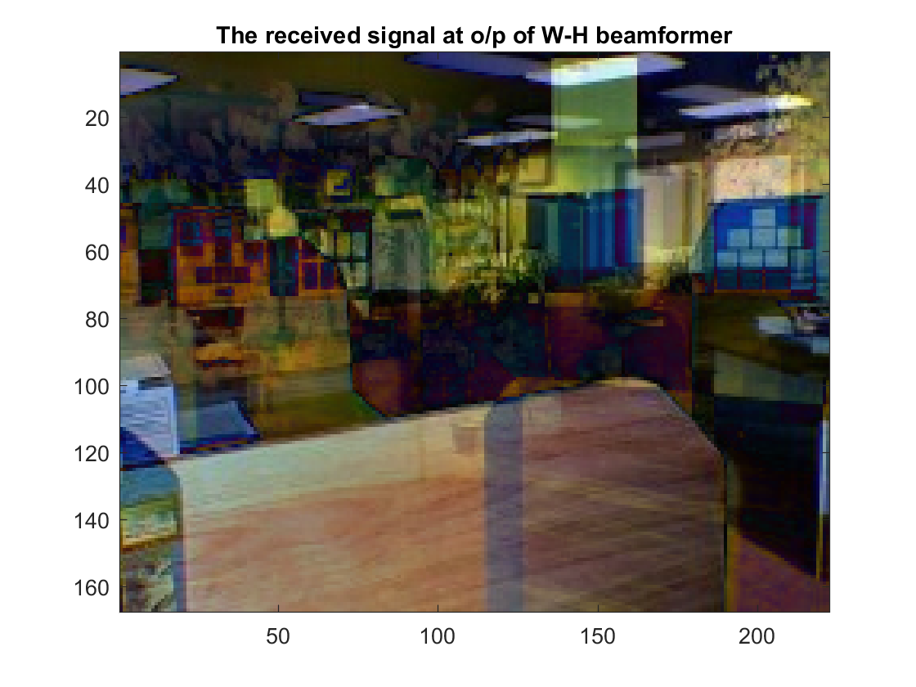

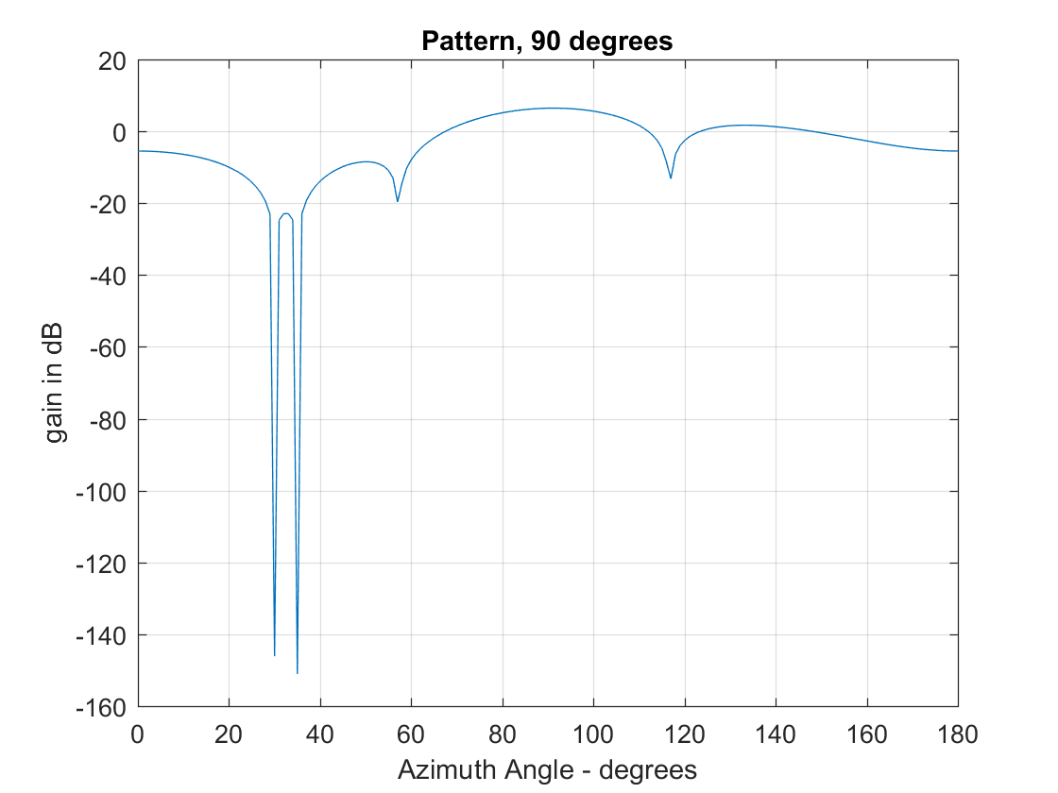Using the multi-beam superresolution beamformer we receive the three following images. Also, the array patterns for each direction of arrival are given. It is clear that the superresolution beamformer performs better than the optimum Wiener-Hopf beamformer since it can suppress completely the effect of the interference.

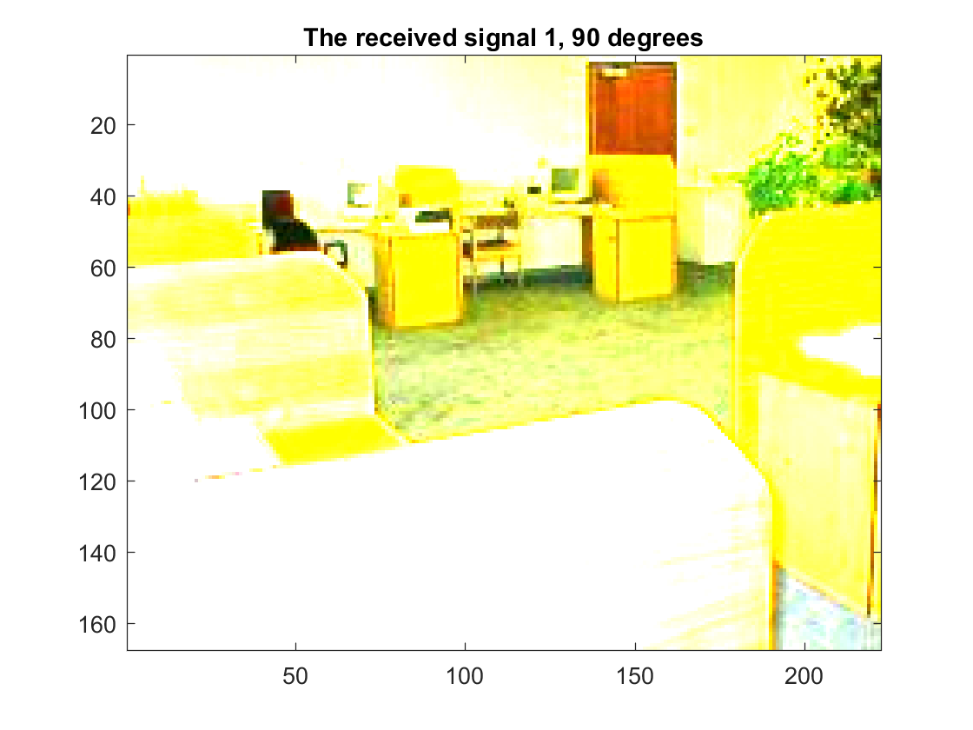

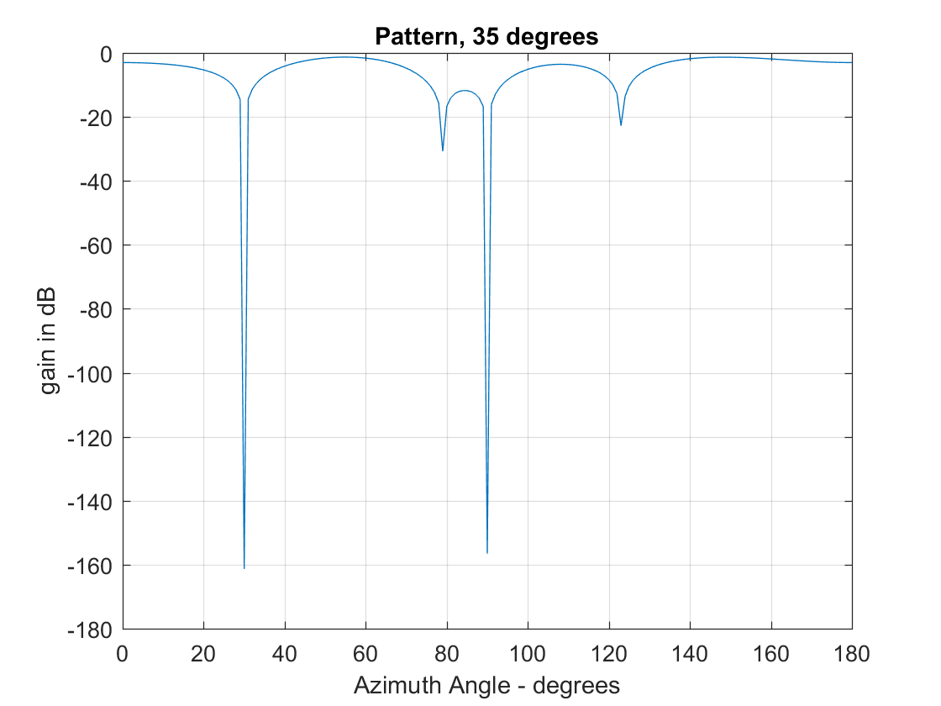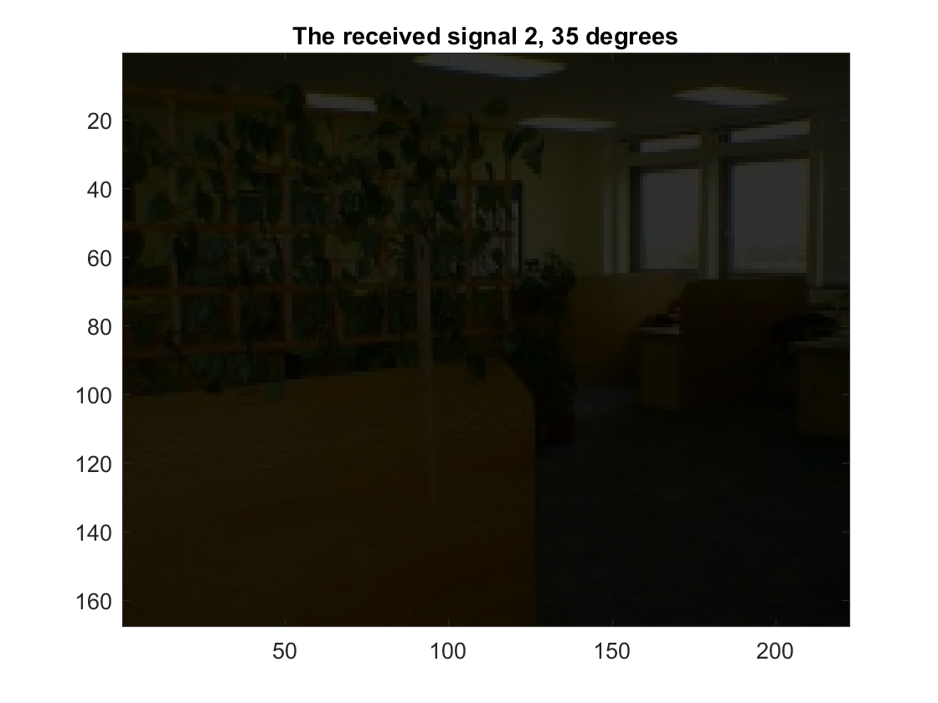

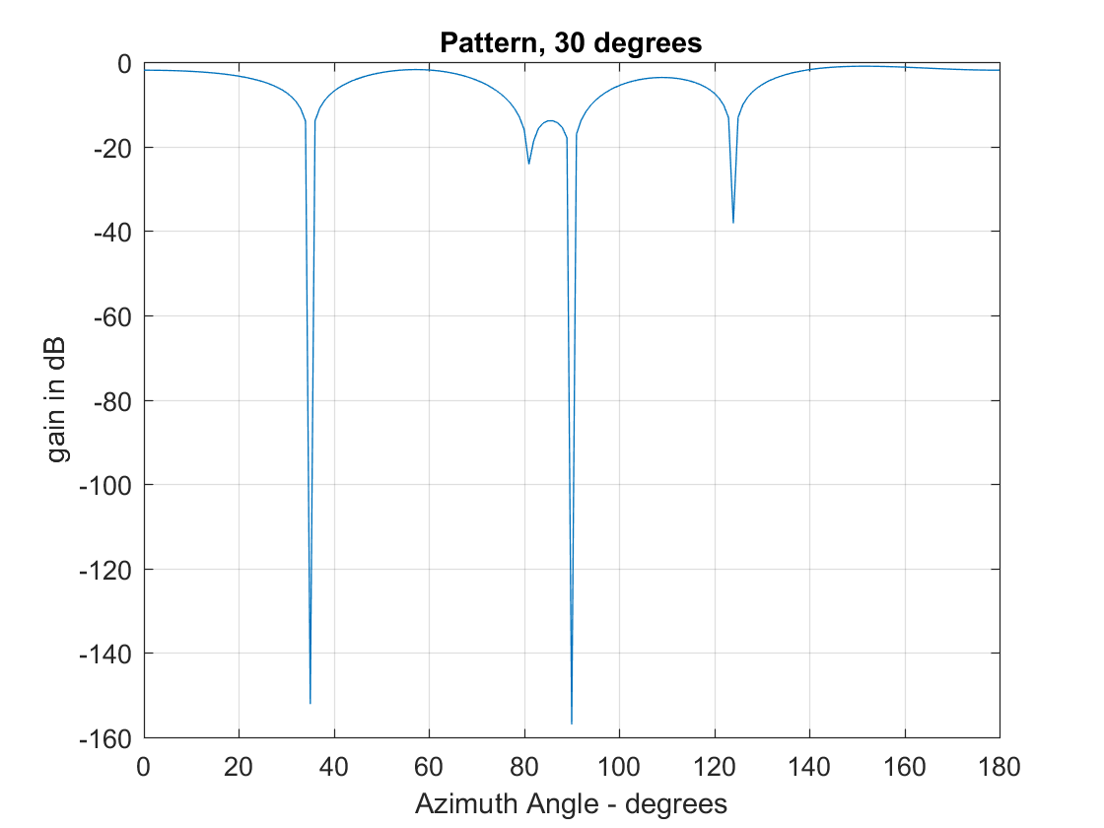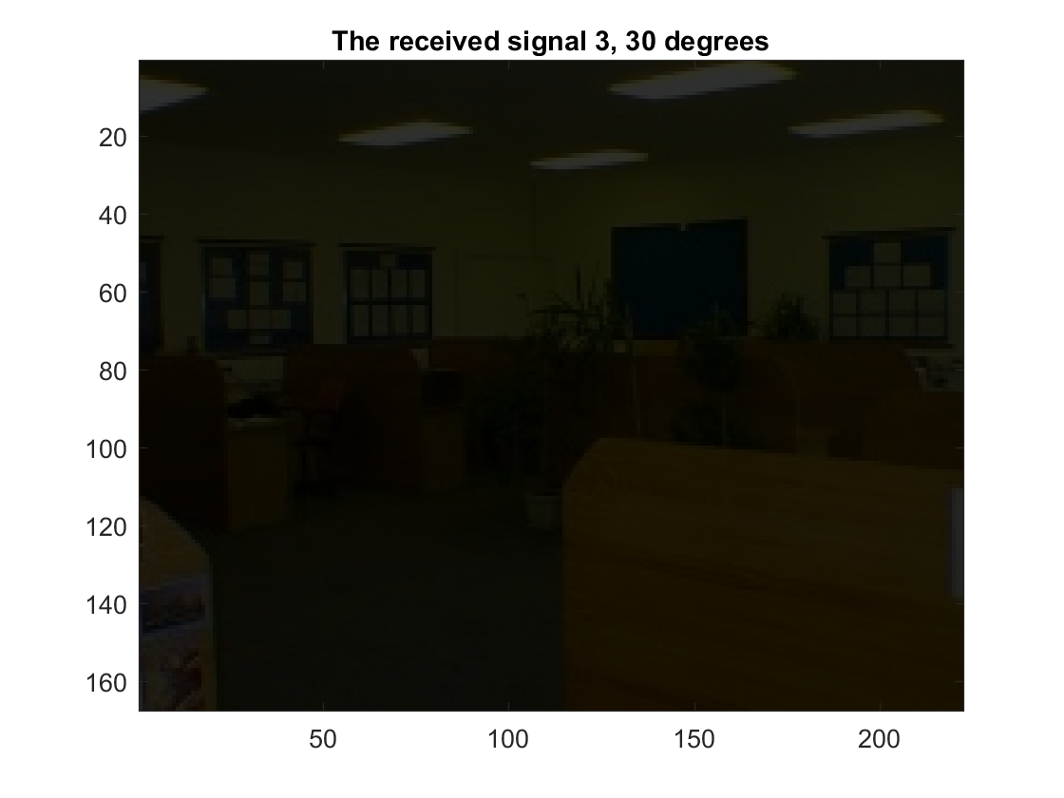

1. By applying eigenvalue decomposition to the practical covariance matrix, one can see that each eigenvalue which corresponds to noise has a different value. Thus, for practical covariance matrices the theorem presented in the fifth question does not apply and neither the power of noise nor the number of sources can be estimated. By applying the AIC and MDL criteria the number of sources can be estimated, and the power of noise can be also estimated using the following expression:

$${\hat{σ}}_{n}^{2}=\frac{1}{N-M}(σ_{M+1}^{2}+σ_{M+2}^{2}+…+σ_{N}^{2})$$

where N is equal to the number of antennas and M is equal to the number of sources.

1. By using the received signals at the 5 antennas and having as desired signal the output of the superresolution beamformer an adaptive beamformer can be designed. The LMS and RLS are implemented and their outputs give us the $w_{opt}$.